Tutorial – 6

**Aim:** Write a shell script which will accept a number b and display first n prime numbers as output.

**Code:**

#!/bin/bash

read -p "Enter the Number: " n

echo "The prime numbers upto $n are: "

m=2

while [ $m -le $n ]

do

i=2

flag=0

while [ $i -le `expr $m / 2` ]

do

if [ `expr $m % $i` -eq 0 ]

then

flag=1

break

fi

i=`expr $i + 1`

done

if [ $flag -eq 0 ]

then

echo $m

fi

m=`expr $m + 1`

done

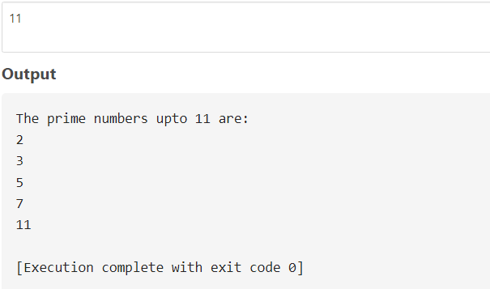**Output:**